NOISE AND VIBRATION CONTROL SPECIFICATION
FOR LIFT INSTALLATION

PART 1 - LIFT MACHINERY

A. ELECTRIC TRACTION LIFTS

The following shall be implemented to reduce noise from lifts:

1. The hoist and sheaves (primary and secondary/deflector) are to be mounted to a single unitized structural base which is resiliently isolated from the building structure. The resilient mounts supporting the base shall be the most effective isolation system provided by the lift manufacturer, but shall not be less than 25 mm effective thickness (either single thickness or layered) neoprene or natural rubber pads and shall provide 2.5 mm static deflection (or 10% strain) under installed loading conditions.

[Items 2 and 3 are only for motor-generator supplied lifts]

2. Mount the motor generators on the most effective isolation system available from the lift manufacturer, but not less than neoprene-in-shear double deflection mounts with minimum 6 mm static deflection.

3. Mount control unit(s) on the most effective isolation system available from the lift manufacturer, but not less than 19 mm thick ribbed or waffled neoprene pads uniformly loaded to achieve 2.5 mm deflection (e.g., Mason Industries type 'Super W', 50 durometer pads uniformly loaded at 310 kPa (45 psi)). Provide a top bearing plate where necessary to uniformly distribute load.

[Items 4 and 5 are only for SCR supplied lifts]

4. Mount the SCR control unit(s) on the most effective isolation system available from the lift manufacturer, but not less than 19 mm thick ribbed or waffled neoprene pads uniformly loaded to achieve 2.5 mm deflection (e.g., Mason Industries type 'Super W', 50 durometer pads uniformly loaded at 310 kPa (45 psi)). Provide a top bearing plate where necessary to uniformly distribute load.

5. Provide an electrical filter/reactor between electric controls and the hoist motor. Mount the reactor on the most effective isolation provided by the manufacturer, but not less than 19 mm thick ribbed or waffled neoprene pads uniformly loaded to achieve 2.5 mm deflection.

6. All bolts through isolation pads shall use resilient washers and bushings, with a minimum thickness of 5 mm, such there is no rigid contact between the isolated base and the securing bolt.

7. All connections to equipment, such as electrical conduit, shall be resilient, to prevent vibration transmission to non-isolated structures/equipment.

8. Double roped systems shall terminate ropes on the unitized resiliently mounted base of the machine.

9. The rollers which guide cars and counterweights along the guide rails shall be of large diameter and shall have solid neoprene rubber tyres. Tensioned steel springs shall be incorporated to maintain a constant force between the rollers and the guide rails. (e.g. ELSCO Express 3 or TOSHIBA spring mounted roller guide)

10. Braking action at the hoist shall be gradual, using fluid damping, so that the application of the brakes does not generate an impact when the brake shoes contact the drum.

11. Guide rails and rollers are to be properly aligned and maintained to obtain the ‘quietest’ operation possible.

12. Guide rails and rollers are to be installed to the most exacting vertical alignment tolerances possible, but no greater than 1.5 mm per 30 m distance. Guide rail bracket shall be positioned at minimum 300 mm above and below slab level.

13. Capsule shall be provided for high-speed lift (8m/s or above). Lift car shall be sound insulated by double-layered structure – thicken car frame and insulation board, guiding device with natural rubber roller, pulley system with dampers and traction machine shall be installed on isolation rubbers.

B. HYDRAULIC LIFTS

The following shall be provided to ensure vibration isolation of hydraulic lift equipment:

1. Provide minimum 25 mm thick neoprene or natural rubber pads between the plunger and the lift cab, designed to prohibit the transmission of vibration induced noise.

2. Mufflers shall be provided between the plunger and the pump to provide smooth fluid flow.

3. The hydraulic pump shall be mounted on a structural base with neoprene-in-shear double deflection isolators with minimum 6 mm static deflection (e.g., Mason Industries type "ND" mounts).
PART 2 – SPRING ROLLER GUIDE AND VENTILATION OPENING

- GENERAL

All equipment shall be quiet in operation and other extraneous noise. Vibration isolation rubber guide wheel, shock absorbing buffers or other means shall be provided where necessary to eliminate vibration or noise transmission.

The Contractor shall take all necessary measures for comprehensive control of noise and vibration from all lift drive equipment and switching, braking, signalling cable movement and lift shaft ventilation. All arrangements for movement shall incorporate noise and vibration control wherever practicable and spring roller guide shall be included (but not be limited to).

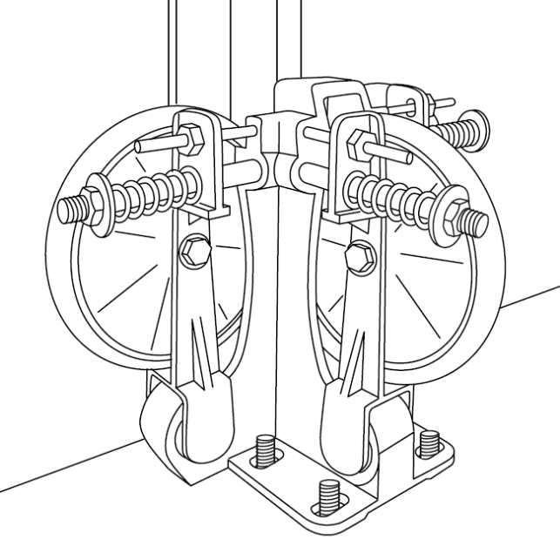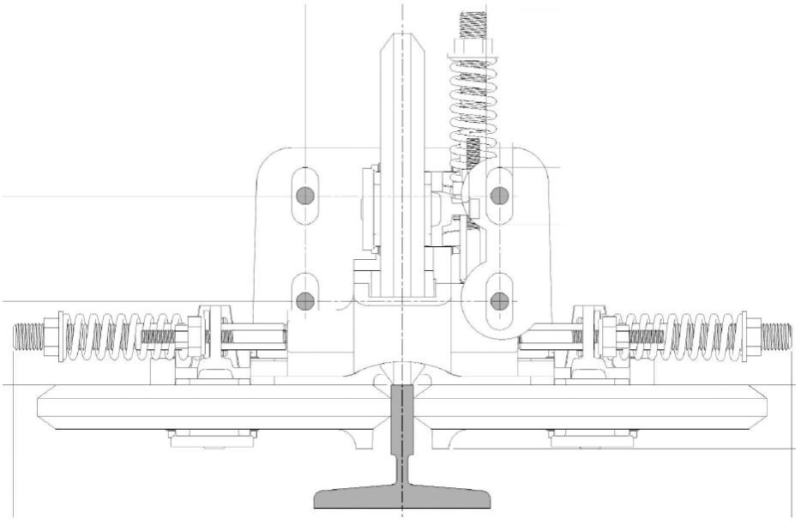
SPRING MOUNTED ROLLER GUIDE, ELSCO Express 3

- SPECIFICATION AND REQUIREMENT

- All vibration isolation described in this section shall be the product of a single manufacturer. Manufacturers to supply products specified in this section shall have a minimum of 10 years documented relevant experience. The products of specific manufacturers are identified to establish type and quality. The Contractor shall have the following responsibilities:

    - Determine spring sizes and locations.
    - Guarantee specified isolation system deflection or natural frequency, such as minimum 5mm static deflection with natural frequency not more than 7Hz.
    - Provide calculations by a licensed engineer substantiating all systems meet applicable building code requirements.
    - Provide installation instructions, drawings and field supervision to insure proper installation and performance of systems.
    - Certify correctness of installation upon completion.
    - Approved manufacturers: ELSCO or TOSHIBA. Products of other manufacturers shall be acceptable provided they comply with specifications and are pre-approved by The Project Engineer.
- Rubber roller wheels shall be high quality neoprene pad and shall be of large diameter (e.g. 150mm).

- All resilient materials are subject to creep and fatigue over time. After installation, the isolation system should be regularly inspected based on system usage. Replace of parts is possible.

- Spring roller guide shall not cause any change of position of equipment resulting in stress on equipment connections.

- All spring roller guides must be sized according to elevator capacity load, elevator speed range, platform dimension. Isolator ratings should be expressed as static deflection /natural frequency based on the actual operation load.

- Details of the proposed noise vibration control measures shall be submitted to the Architect for approval. Substitution or deviation from the vibration isolation specified in this section shall be acceptable as long as the equipment manufacturer provides written guarantees that specified noise and vibration limits shall be met. Any costs to remedy noncompliant conditions shall be fully borne by the Contractor.

- VENTILATION OPENING

Lift shaft shall have ventilation opening, reduce the aerodynamic noise due to piston effect, the following is the general recommendations.

Recommendations for Lift Ventilation Opening
Lift for Towers | 2.5m/s or below | 2.5m/s to 5m/s | 5m/s or above
Single lift shaft | Top lift vent only.  Not less than 0.15m2, to be advised by lift manufacturer | Top & Bottom lift vent.  Not less than 0.15m2, to be advised by lift manufacturer | Top, Bottom & every 3-5 floor.  Not less than 0.15m2, to be advised by lift manufacturer
Common lift shaft | Top lift vent only.  Not less than 0.15m2, to be advised by lift manufacturer

PART 3 - ESCALATORS

A. GENERAL

All equipment shall be quiet in operation, free of rattling, clanking and other extraneous noise. Sound reducing rubber pads, shock absorbing buffers, acoustic fiberglass linings or other means shall be provided where necessary to eliminate vibration or noise transmission.

The Sub-Contractor shall take all necessary measures for comprehensive control of noise and vibration from all escalator drive equipment and switching, step movement, trips, braking, signalling handrail movement and escalator pit ventilation.

All arrangements for movement shall incorporate noise and vibration control wherever practicable and shall include (but not be limited to) the following:

(a) Careful citing and alignment of tracks with inserts to moving parts to discourage noise and vibration during movement.

(b) Careful locating and detailing of trips and braking equipment to limit impact noise transmission into the structure.

(c) Use of elastomeric step rollers and step chain rollers.

Details of the proposed noise vibration control measures shall be submitted to the Architect for approval.

B. ESCALATORS CLADDING

The external cladding shall be adequately stiffened/damped to avoid any rattling or squeaking noise.

PART 3 – ACOUSTIC PERFORMANCE

The maximum permissible sound pressure levels in octave band of lift in operation shall comply with the following NC levels. The measurement location shall be 1.5m from lift shaft.

Space | Background Noise Criteria (NC)  Design Target
Conference Rooms | NC25 (35dBA)
Office type premises: Security Control Room & Management Offices / Network Operation Centre /Office | NC35 (40dBA)
Occupied Space  - NC40  - NC45 | NC35 (40dBA)  NC40 (45dBA)

The maximum structural borne vibration levels that generate by lift motor, lift car and elevator pass-by in RMS velocity, with 1/3 Octave Band filtering, shall not exceed 400µm, in any frequency band from 4 Hz to 500 Hz, for any one second average measured at any point of a concrete floor or wall on an occupied space. The measurement shall be performed and comply with the requirement of ISO 2631-2 “Mechanical vibration and shock – Evaluation of human exposure to whole body vibration – Part 2: Vibration in buildings (1Hz to 80Hz)”.

Noise levels resulting from operating any lift shall not exceed 55dBA and 5dB above background sound level at 1m from the lift door when the lift is operated in-situ at its rated speed and loading.

Noise levels resulting from operating any escalator shall not exceed 55 dBA at 1m from the upper or lower landings when the escalator is operated in-situ at its rated speed and loading.

END OF SECTION

